**Overview**

The following lab has been designed to be completed on a system running MS Windows. If you are using MacOS, Linux, or are uncomfortable doing the lab tasks on your own system, you can download the “COMP-CO910-Labs.ova” file from the course VM collection and open it in Oracle VM Virtualbox (your professor will discuss this process with you if needed).

If you have experience on the Windows desktop you may find that the step-by-step instructions feel unnecessary – and, for you, perhaps some of them are! I recommend, however, that you follow all the instructions as there are lab questions scattered throughout that you may have difficulty answering if you have not followed along. I have highlighted the spots where you need to provide answers in red.

**Outcomes**

This lab is designed to familiarize you with basic file and directory management on a common OS. You will also do some personal research to answer additional lab questions related to the exercises.

|  |  |
| --- | --- |
| Elements of Performance | Related Course Learning Outcomes |
| EOP 2.3. Identify and manipulate files and directories | CLO 2. Understand the role of operating systems |
| EOP 2.1. Gain awareness of modern operating systems | CLO 2. Understand the role of operating systems |
| EOP 2.2. Contrast and compare GUIs vs. CLIs | CLO 2. Understand the role of operating systems |

**Time on Task**

|  |  |
| --- | --- |
| Learning Activity | Approximate Time |
| Perform hands-on lab tasks and answer lab questions | 30 min |
| Read, research, and write answers to research section | 45 min |

Let’s get started!

**Lab Steps and Questions**

1. Log into MS Windows and start the File Explorer. You do this by clicking the icon in the bottom-left corner of the screen that looks sort of like a window pane (it’s called the *Start Menu*) and when the menu appears either clicking “File Explorer” (if it’s visible) or typing “File” and selecting the icon for the “File Explorer” app that will appear at the top of the menu:

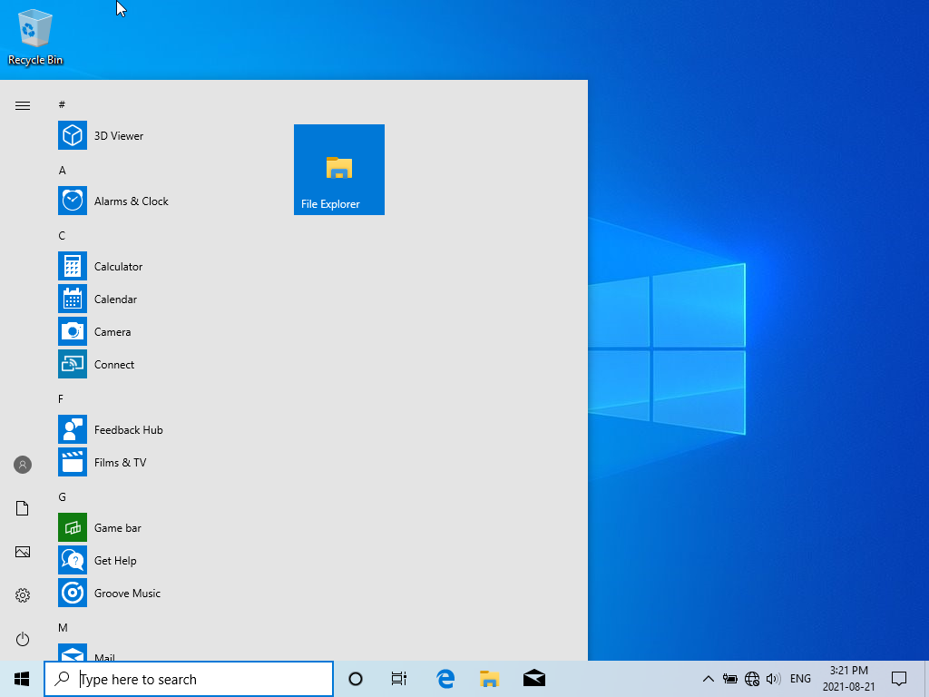

If you perform these steps correctly you will see the File Explorer application appear. Its window will have a shortcut area on the left that lets you quickly move between commonly accessed folders, a centre pane that will highlight frequently accessed folders and recently accessed files (these will likely look different on your system than the pictures here show because the way you use your computer will inform what populates these areas), and a menu and navigation area at the top:

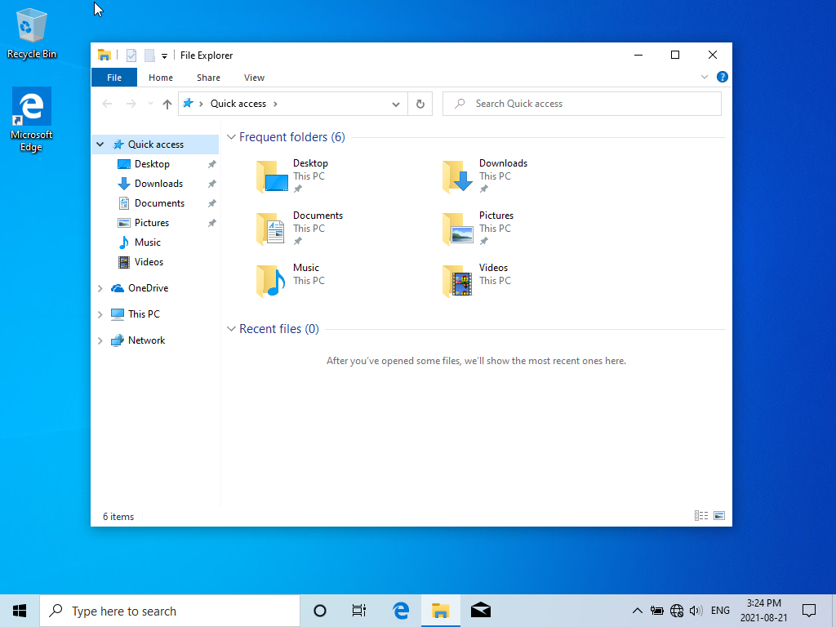

1. Double click the icon labelled “Desktop”:

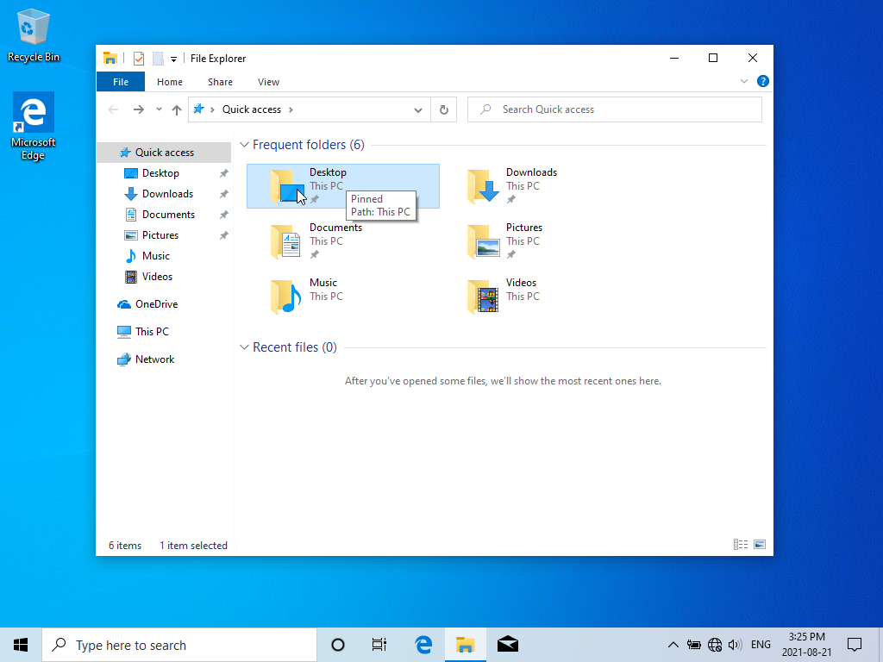

The centre pane will now show you the contents of your “Desktop” folder. Again, your Desktop folder will more than likely have different contents than ours and therefore look different than the sample image we have here in the lab:

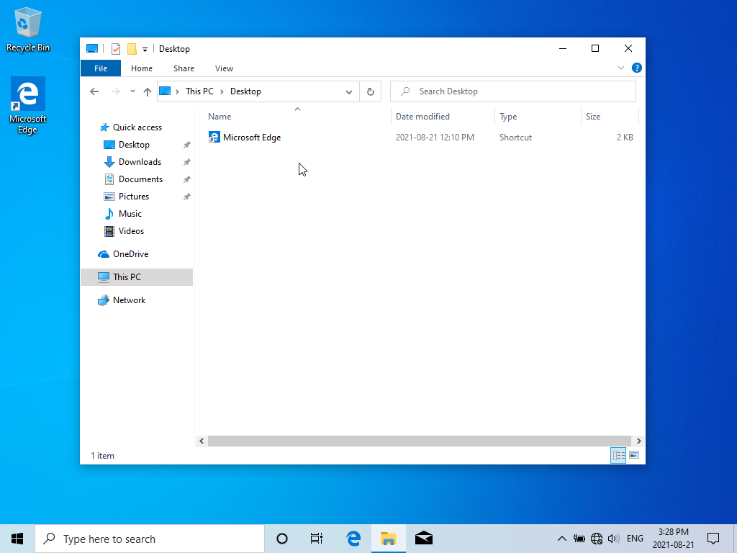

1. Right-click in the file list area and select the “New” item from the menu

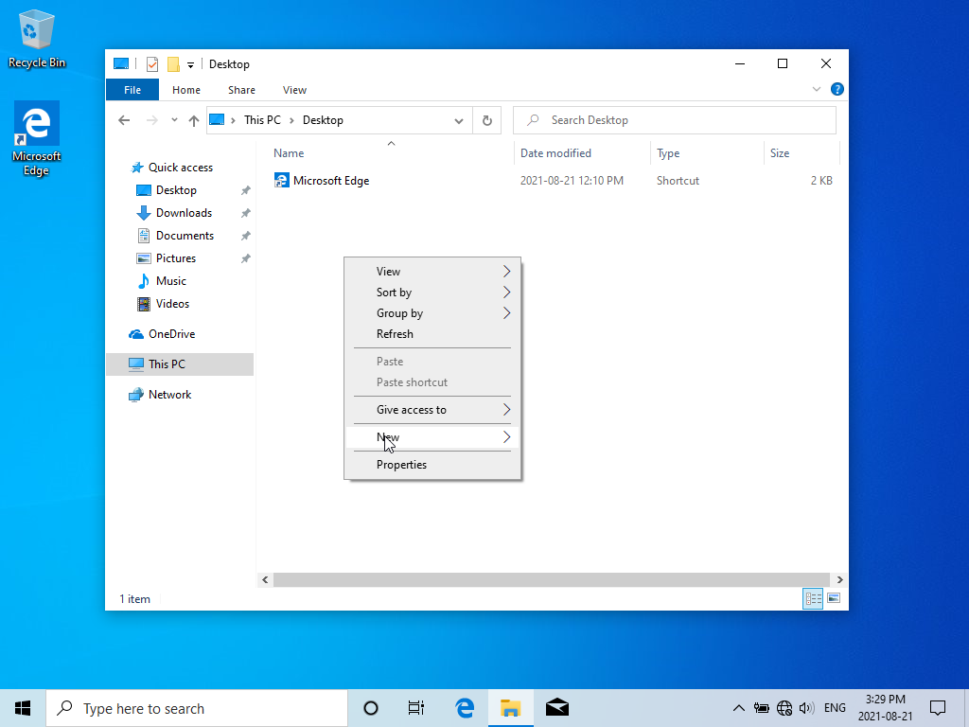

Select “Folder” from the options presented but DO NOT PRESS ENTER YET!

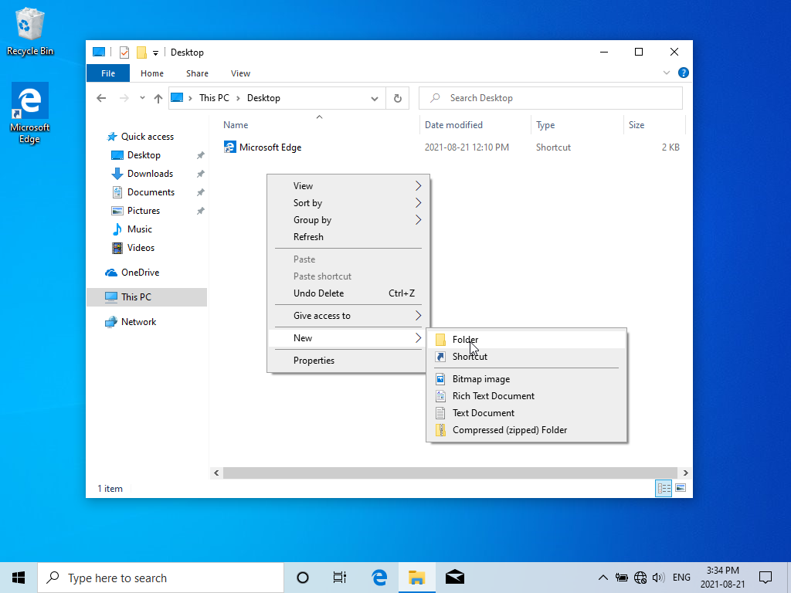

You will see something that looks like this (of course, you will likely have other stuff here, but you get the idea):

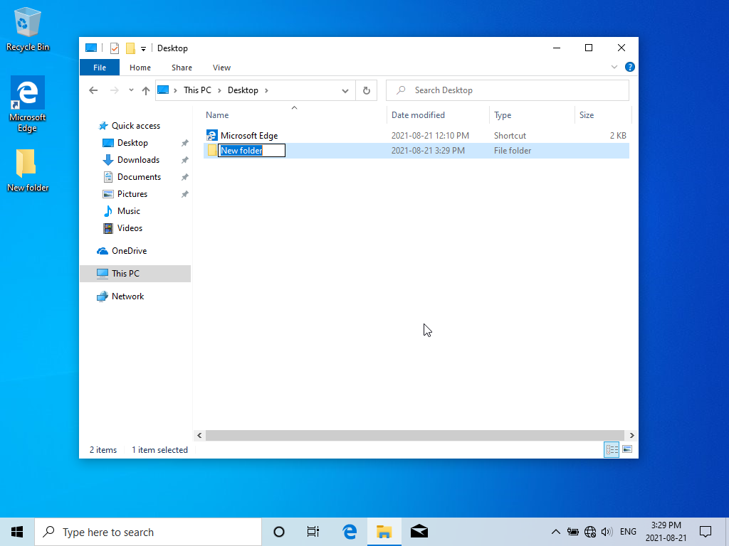

1. You will now give this new folder a name – try typing the name **":Hello!:"** (with the quotes).

Question: What happens?

Error: Can’t use special characters. It only allows me to name the folder Hello!, no : or “ allowed

Try leaving off the quotes.

Question: What happens?

Error: Can’t use special characters. It only allows me to name the folder Hello!, no : allowed

Let’s use a completely different name – let’s see if I’m trying to trick you here by typing **CON** and pressing Enter.

Question: What happens?

The specified device name is invalid.

Oh, well. Use your name instead.

Question: What happens?

It works properly. I was able to name my folder Wilder

1. Now, right click in the file list area and select “New” again. From the list presented, pick “Text Document” but after you do so, DO NOT PRESS ENTER YET!

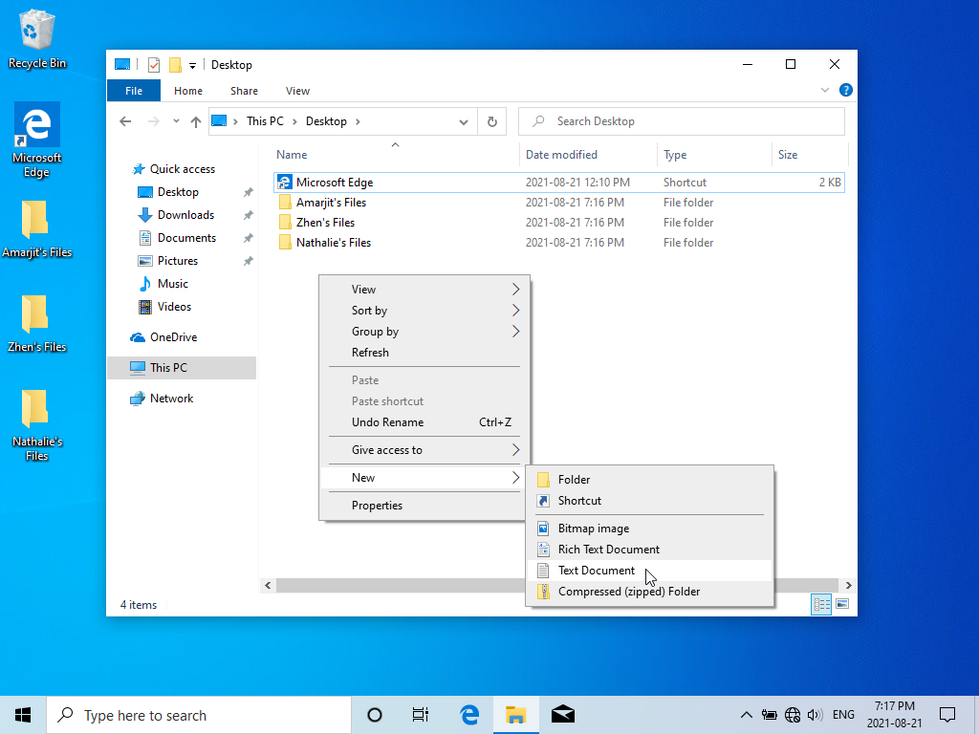

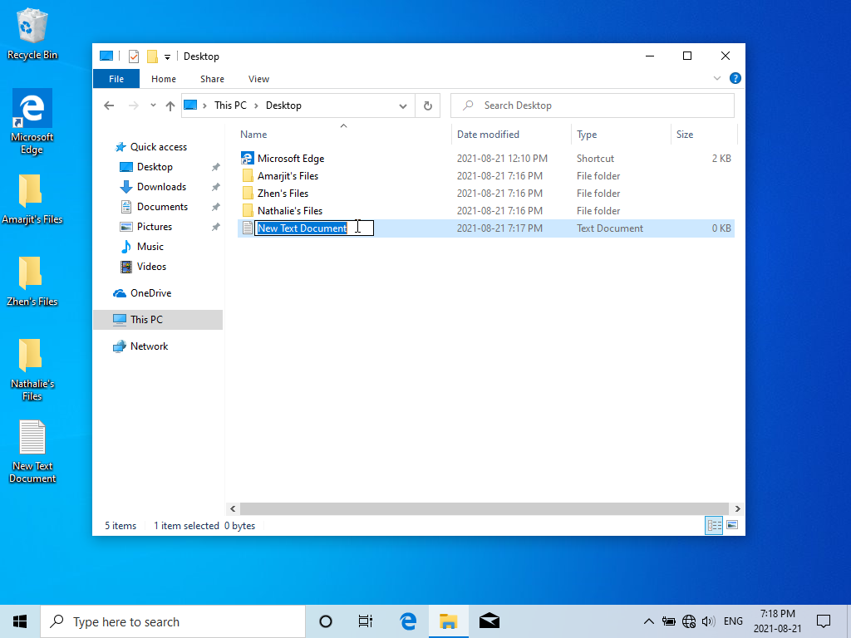

Let’s pick our own file name. Try using **":Hello!:"** again!

Question: What happens?

Same error I got before. Can’t use special chars in the name.

Hmm, well, we can try leaving off the quotes again. See if that works!

Question: What happens?

Same error as before. : is a special char.

Let’s use a completely different name – try typing **AUX**

Question: What happens?

The specified device name is invalid

Oh, well – we could have predicted that! Use your name instead.

Question: What happens?

It works! My .txt file is now named Wilder

1. Now we have a file and a folder that we have just created. Let’s see what we can do with it!

Double-click the **file** with the left mouse button.

Question: What happens?

It opens the file in notepad

Question: Why do you think that particular application appeared   
 (why not a picture viewer, for instance)?

Because notepad is the default editor for .txt files. A picture viewer would make sense if my file was an image or gif.

Go ahead and close that application. You can use the “x” button in the top right corner, or click the File menu and select Exit.

1. Now, click and hold the file with the left mouse button, then drag the file until it is shown on top of the folder you created earlier, then let go of the mouse button.

Question: What happens?

When I hover over the folder it says Move to folder. When I let go of the mouse the file disappears. When I open the folder the file is inside.  
It moved the file into the folder.

1. Double click the folder you created earlier.  
     
    Question: What happens?

It shows me the contents of the folder. Currently it is only showing me the .txt file I made called Wilder.

1. We’re now going to put the file back where it was before! Right click the file and select “Cut” from the menu that appears.

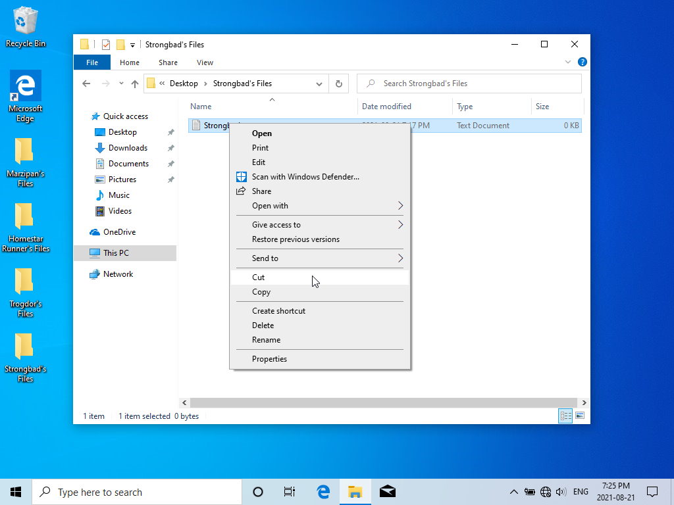

Question: What happens?

The file is selected and it became greyed out a bit or transparent after I chose Cut.

Next, click the word “Desktop” in the navigation bar OR click the left arrow at the far left of that bar.

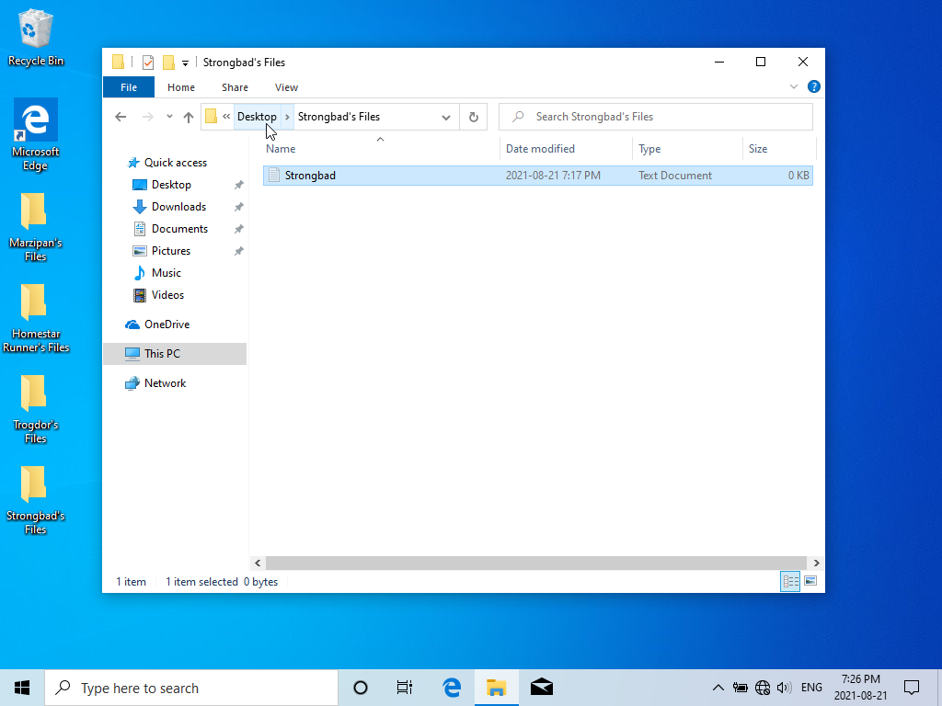

You should be back at your Desktop folder. Right click in the file list area and select “Paste” from the menu.

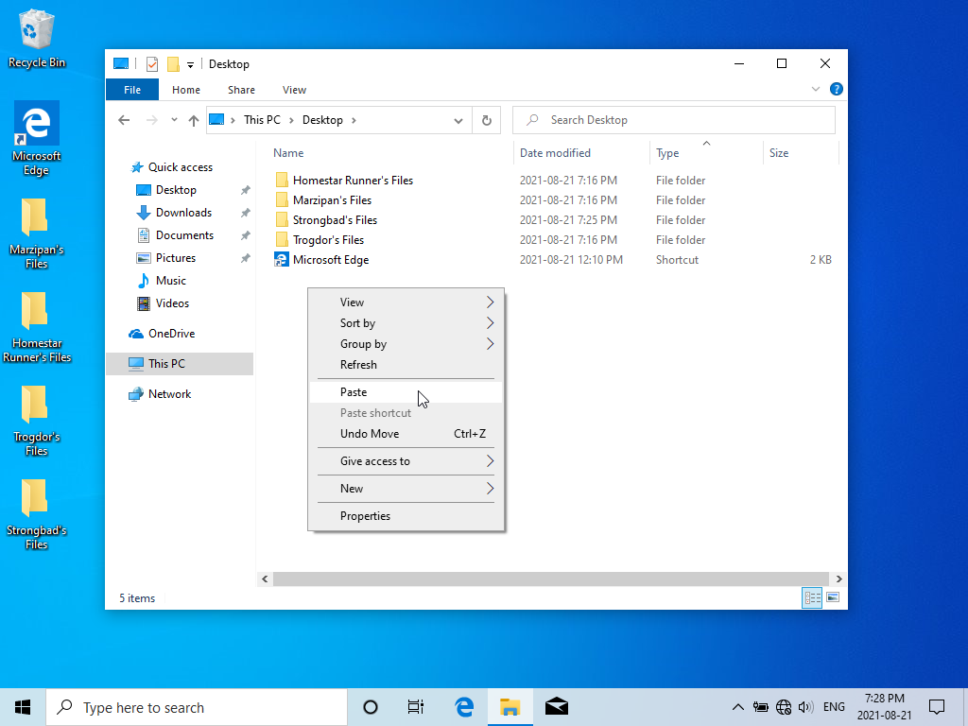

Question: What happens?

The .txt file that was inside the Wilder folder is now back in the main directory it was before.   
*I am using Documents not Desktop due to privileges on the school computer.

Congratulations! You’ve successfully created a *folder* on a Windows OS! You also created an (empty) *file*, which you moved into the folder, then moved back.  
  
Question: What is the difference between a file and a folder?  
  
 A file is something that has media and file size associated with it. Files are the content. Files can’t contain other files or folders.  
A Folder is a way to organize your files. Folders have files folders inside them, but Files can’t have folders inside them.

1. We have not yet explored (yes, that was a joke – not a good one, but a joke nevertheless) the application we’re using to create and manipulate these objects. Click on the “Quick Access” header located on the left-hand side of the window:

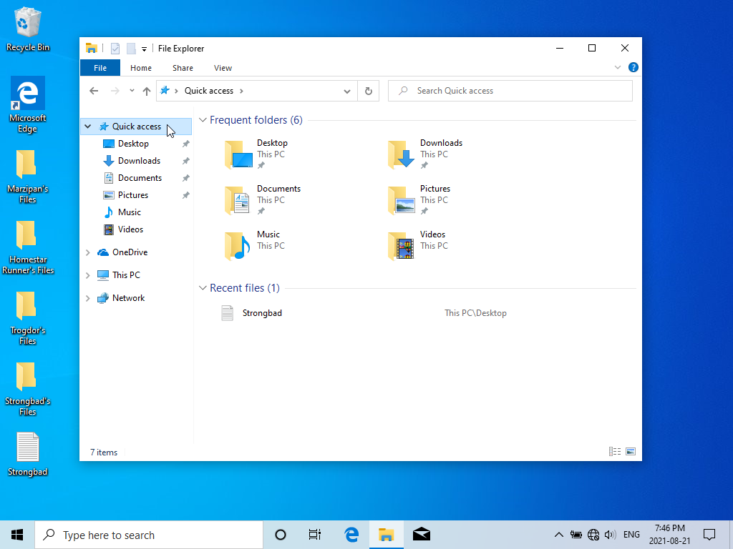

Just looking at this on your own system it’s clear that there are several different types of files. You can tell the difference between them because the OS (and this application) represents them with different types of *icons* (the little pictures). We created an empty text document, which is represented by an icon that looks like a little piece of paper. You may have other icons representing other types of files – pictures (often represented by a small version of the image), videos (also often represented by a small picture of part of the video), documents, music, etc.

Of course, we also have folders visible here. Another word for a folder is a *directory*. The purpose of folders is to help you organize your files. Have you ever used a USB drive (or even someone’s computer) where all the files were dumped in one place? It quickly becomes impossible to find what you’re looking for! We put files (and other folders!) inside folders to keep them structured. The icon for a folder resembles an old manila file folder, and you may notice that an empty folder is shown as an empty file folder, but after adding documents and files into it the icon shows those items within the folder.

The navigation bar (also called the address bar) at the top of the window shows you “where you are” in the logical path through the structure of folders on the computer.

If you’re not already looking at the “Quick access” view in the File Explorer, return there. From this screen, double-click on the “Desktop” folder:

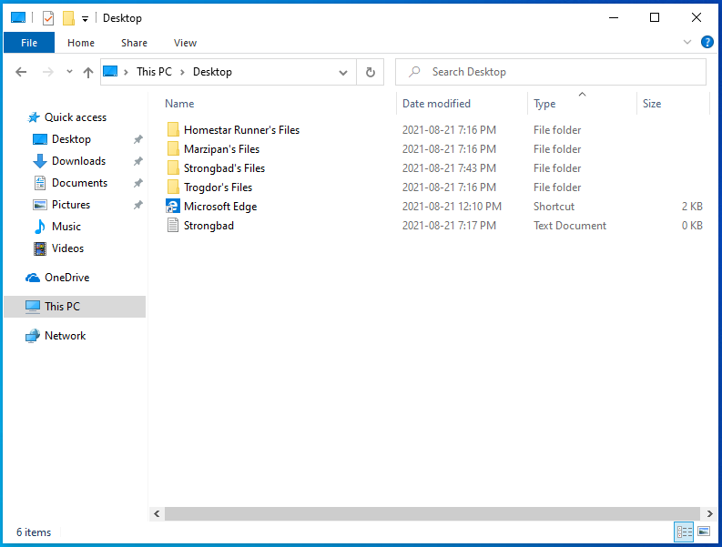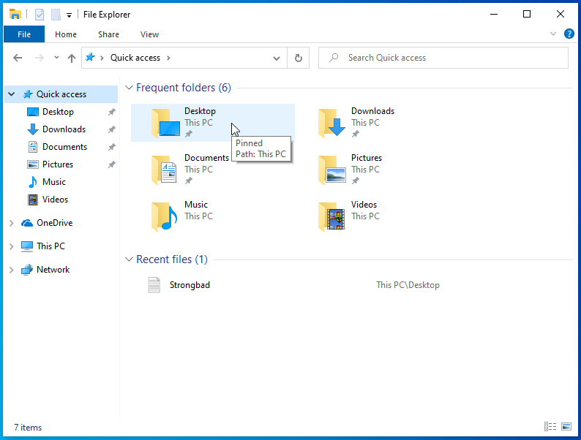

1. The centre pane contents should now reflect the contents of your Desktop folder. If you minimize this window you should see these contents reflected on your workspace desktop – to minimize your window you can click the horizontal line on the upper right hand corner of the window (it’s near the x that closes the window).

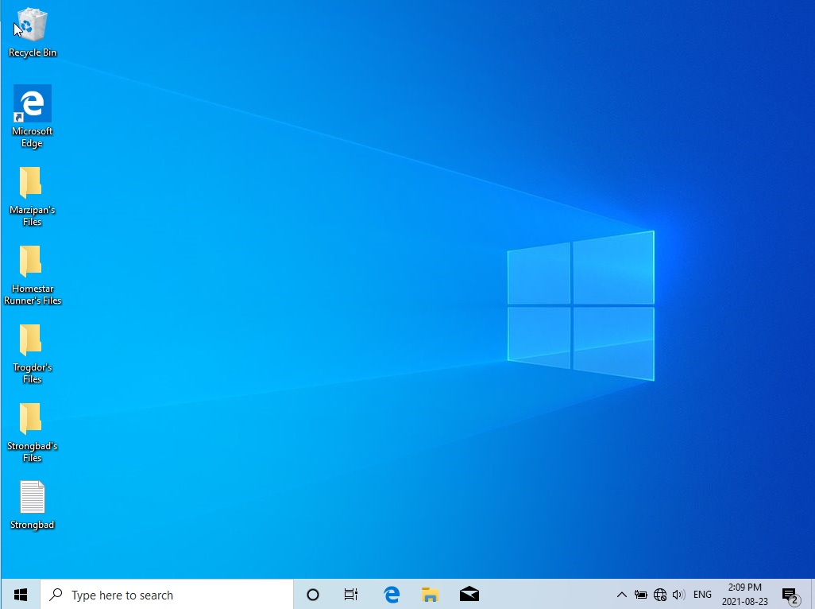

Return the File Explorer window to its original location by clicking the icon for it in the task bar at the bottom of the screen (if you leave your mouse pointer hovering over the icon a small representation of the window will appear over the icon):

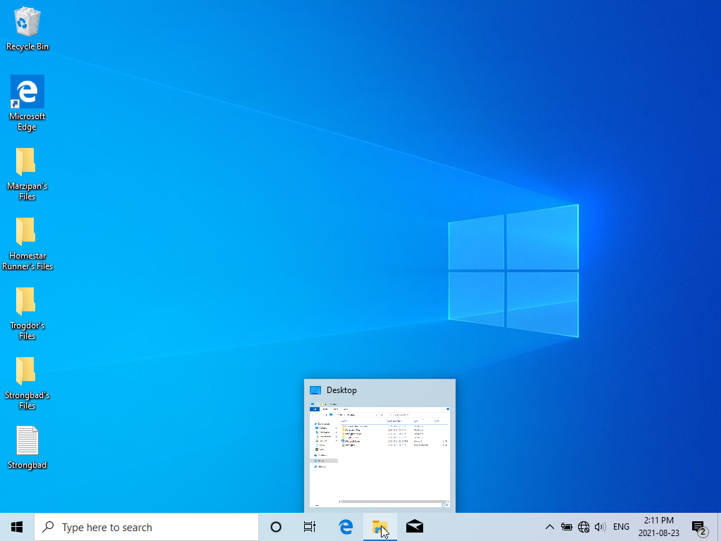

1. With the window open again, left-click on the file you created earlier to *select* it. Once it is highlighted, right-click on the file and select “Delete” from the menu that appears (if you don’t see “Delete” in the menu it is because the file was not selected – left click somewhere else briefly and try left-clicking the file again and ensure that it is properly selected):

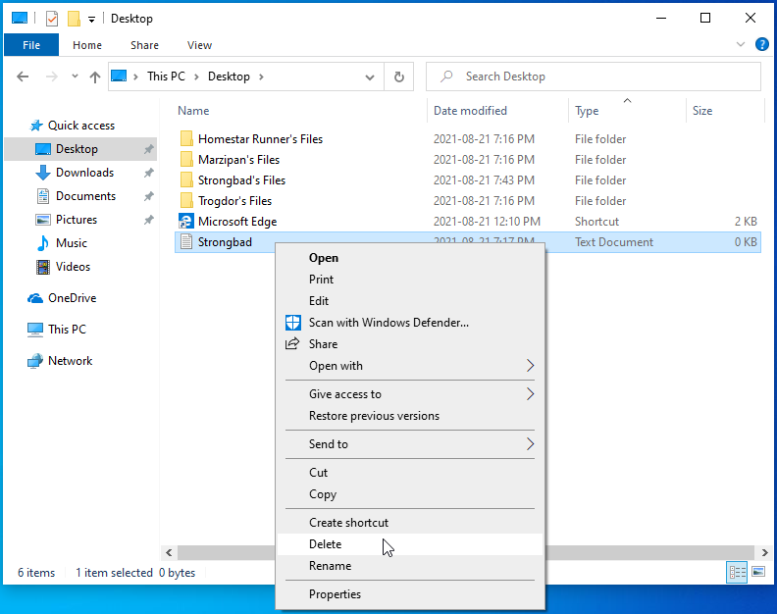

The file should disappear from the view of your Desktop folder in the File Explorer. Check to see if it is really gone by once again minimizing the File Explorer window once again and examining the Desktop.

If you followed these steps correctly your file will not be visible on the Desktop – this is not a surprise because, after all, you just *deleted* it. Deleting a file removes it from its location on your *file system*.   
  
A file system is what we call the organizational structure imposed on our disk when it was *formatted*. We discussed this in class, but if you have further questions I encourage you bring it up now and make sure this idea is clear to you.

1. 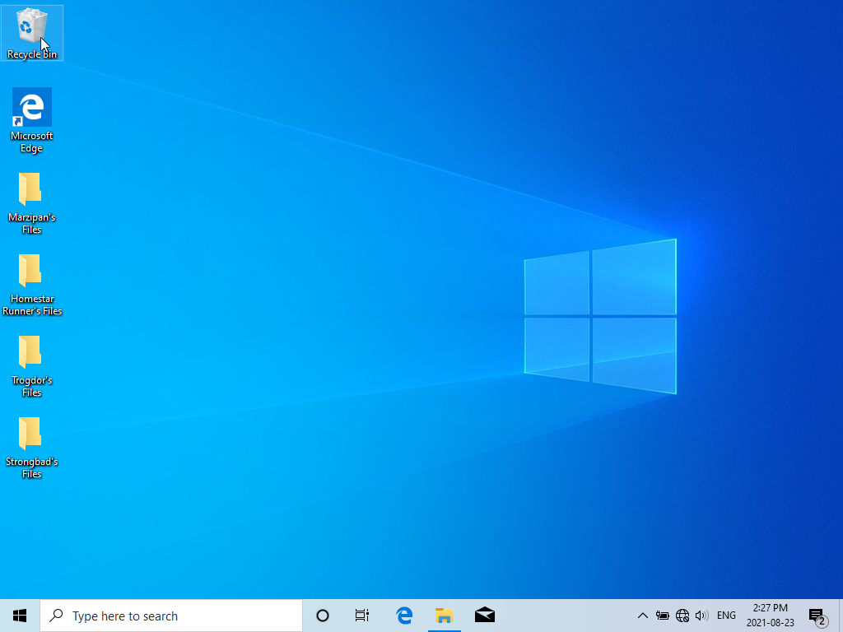Double-click on the icon that is usually in the upper-left hand corner of your workspace desktop and is named “Recycle Bin” (naturally, it looks like a recycling bin):

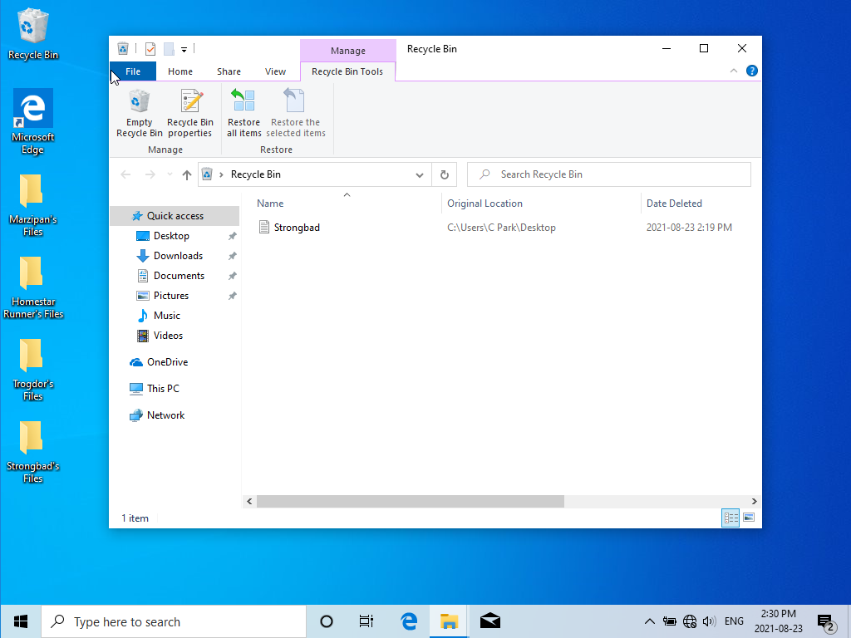

1. You’ll notice that the file you just deleted is here! You’ll also notice that below the menu bar there is a *ribbon* active – it should be showing the “Recycle Bin Tools” icons. Feel free to explore what else can be done in this window by clicking on the Home, Share, and View menus, each of which will change the contents of the ribbon – don’t click any of the other icons, though, and make sure you finish up with the Recycle Bin Tools ribbon active.   
     
   Left-click the file that you deleted earlier. You will notice that the “Restore the selected items” icon has become brighter. Left-click **below** your file to deselect it. Observe the “Restore the selected items” icon – it is now dim again – we call this state *greyed out* (because it’s now light grey in color) and it means that we can’t use that function right now. If you right-click below your file you will see a menu appear:

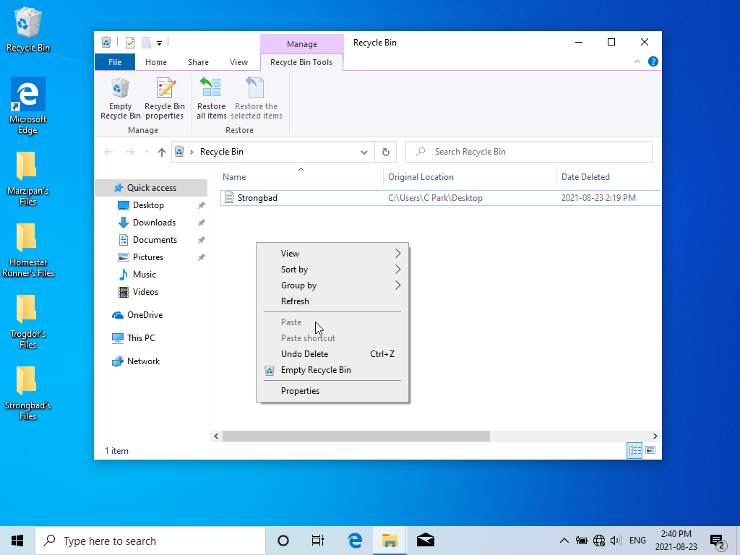

Note that “Paste” and “Paste shortcut” are greyed out, and that you cannot click them.

1. Select your file, then right-click on it. Choose “Restore” from the new menu:

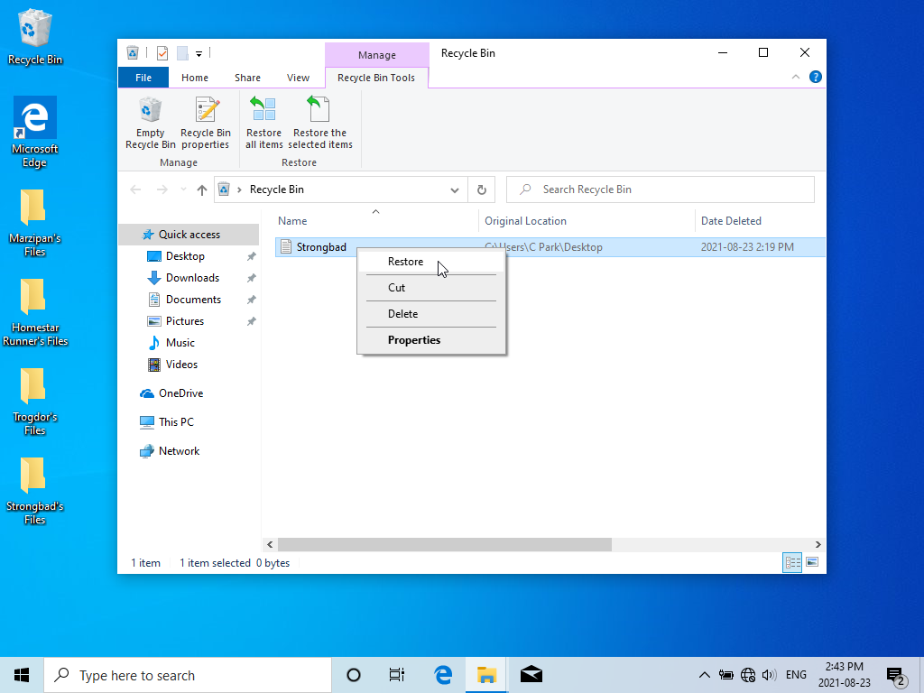

The file should vanish from the Recycle Bin and reappear on your workspace Desktop:

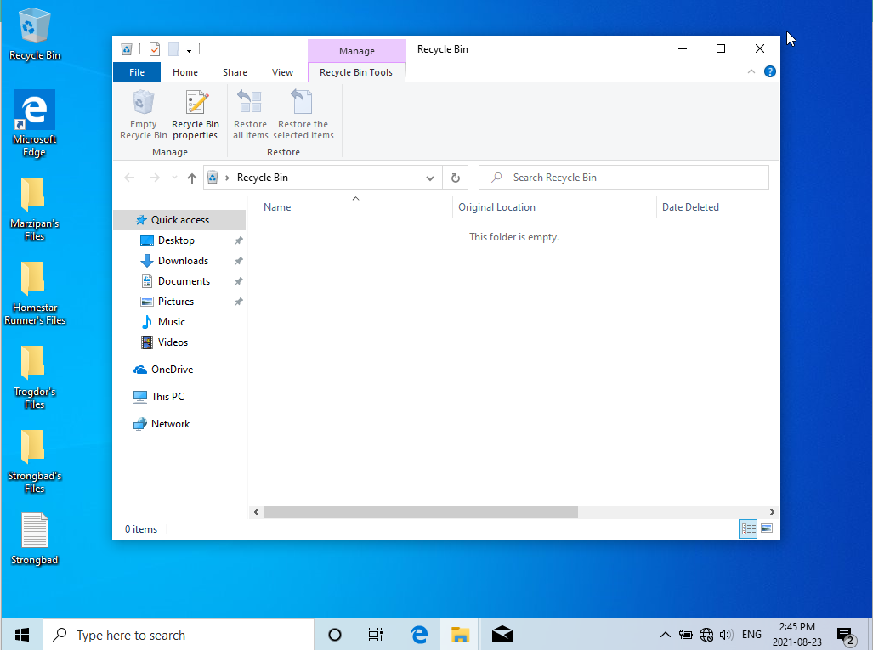

Close the Recycle Bin window, then restore the File Explorer window so that you can see your file listed in the Desktop folder.  
  
Select your file, then right-click to display the menu. Pick “Copy” from the menu.  
  
 Question: What happened?  
  
 Nothing. It’s different than when I selected Cut and it greyed out. I can’t tell anything happened when I hit Copy.

Unselect your file – the easiest way is to click in the open space below the list of files in this folder. Right-click in that same open space and note that in the menu that appears both “Paste” and “Paste shortcut” are **not** greyed out.  
  
 Question: Why do you think they are able to be picked and not greyed out?  
  
 Because I have now selected something to the Copy. I must have something copied to be able to Paste it or Paste Shortcut. Copy comes before Paste.

Go ahead and pick Paste from the menu:

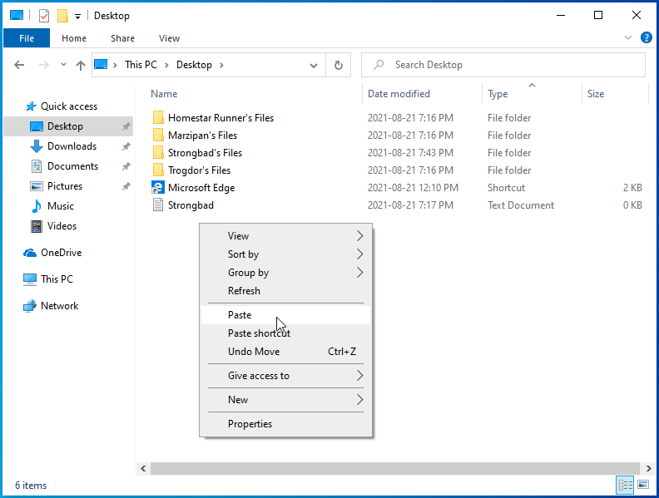

Question: What happened?  
  
 It pasted the file, but renamed it to include – Copy. So now I have 2 .txt files. One Wilder and one Wilder - Copy

1. Select the new file, then right-click it to bring up the menu. Pick “Rename” from the menu:

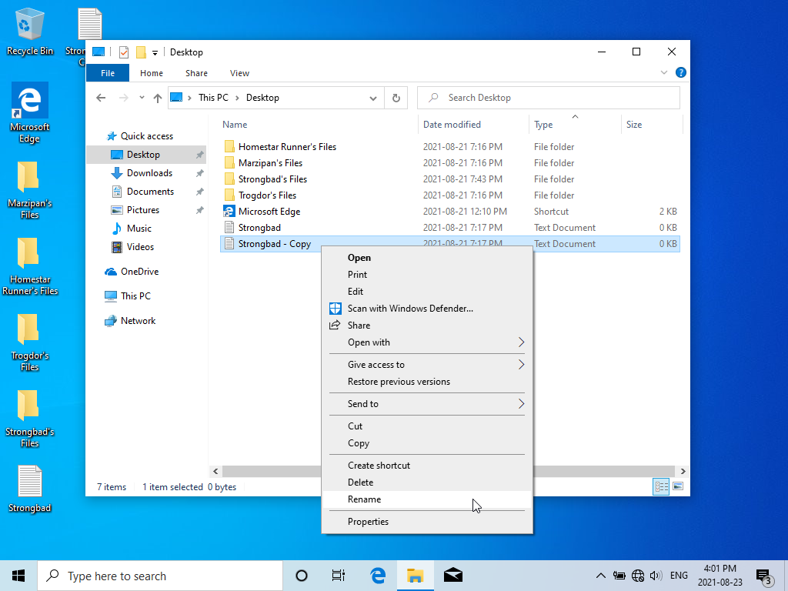

Of course, your file will be different, but it should look something like this:



1. The text colour has been inverted (it’s now white on a dark background) because it has been selected (yes, we use this word a lot and it doesn’t always mean the exact same thing, but rather the same general concept). If it is not inverted in colour as in the above example it is likely because you clicked somewhere in the box – let’s fix that by left-clicking on the far right of the text **and holding down on that left mouse button, dragging the pointer to the left-hand side of the text**. The text should now be selected like it was before ☺.  
     
   Let’s pick a new name for this file. Type the name of the original file (it’s the same name it has now, but without “ - Copy” at the end) and hit Enter.  
     
    Question: What happened?  
     
    It asks me if I want to rename. There is already a file with the same name in this location. It has suggested I can the file Wilder (2)
2. Click “No” in the dialog box – we don’t want that new name ☹.  
     
   Right-click your file again, and once more pick “Rename” from the menu. When the text is selected go ahead and type a new name and press Enter:

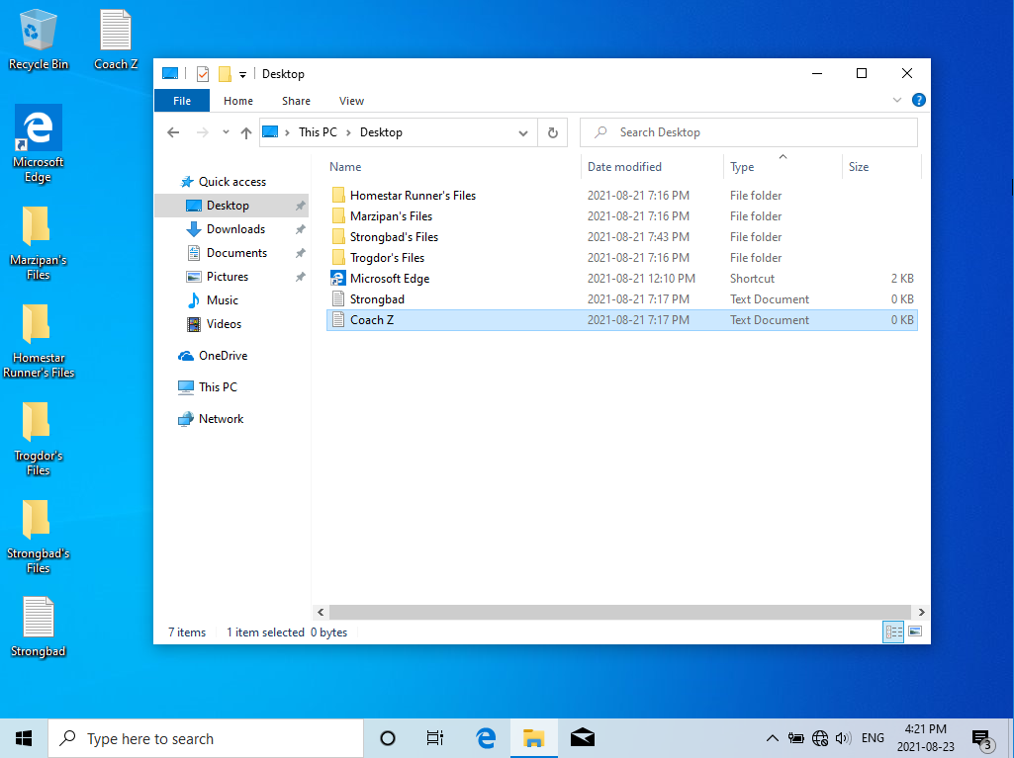

You should see that your new filename has been applied to the file. If you can see the icons for your files on the Desktop you’ll see that it changed there too – and that makes sense because we have changed the file name on the file system and not simply changed what’s displayed in the File Explorer, so every place that we can view the file it will have the new name.

1. Really? Let’s test that. Left-click the Start menu, then type **cmd**. You should see that an app called “Command Prompt” is being suggested:

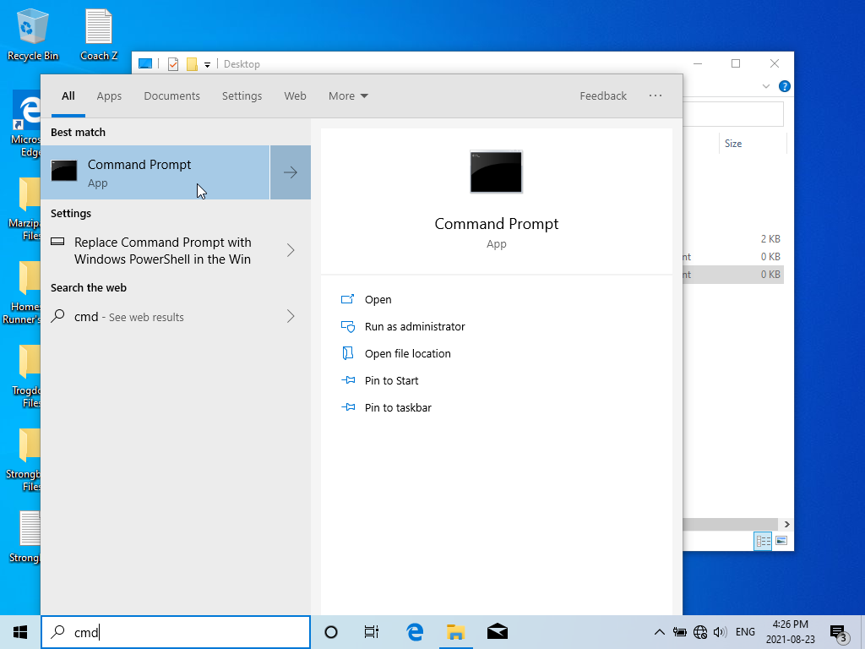

Pick that one by left-clicking it.

Question: What happened?  
  
 A black console appeared called Command Prompt.   
The text in the windows says:  
Microsoft Windows [Version 10.0.19045.5247]

(c) Microsoft Corporation. All rights reserved.

C:\Users\000970878>

1. The new window that appears will have some familiar text in it – at the very least you should recognize the name you used to log into the computer. Type **cd Desktop** and press Enter. ***NOTE:*** if this fails it may be that your Desktop folder is within a OneDrive folder, so you may need to type **cd OneDrive** before **cd Desktop**  
     
   Once you are in your Desktop folder type **dir** and press Enter.   
     
    Question: What happened?  
     
    I am using Documents so I went cd Documents, ENTER, dir, ENTER>  
   I now have a list of what I think are folders and files. Looks like DIR stands for directory or folders.  
     
   Output: C:\Users\000970878>cd Documents
2. C:\Users\000970878\Documents>dir
3. Volume in drive C is Windows
4. Volume Serial Number is 1234-ABCD
5. Directory of C:\Users\000970878\Documents
6. 2025-01-27 12:31 PM <DIR> .
7. 2025-01-27 12:31 PM <DIR> ..
8. 2024-08-22 07:30 PM <DIR> IISExpress
9. 2025-01-10 11:29 PM <DIR> Inventor Interoperability
10. 2024-08-22 07:30 PM <DIR> My Web Sites
11. 2025-01-27 12:10 PM 0 Stubbs.txt
12. 2025-01-27 12:17 PM <DIR> Wilder
13. 2025-01-27 12:10 PM 0 Wilder.txt
14. 2 File(s) 0 bytes
15. 6 Dir(s) 248,886,870,016 bytes free

You’ll likely have different files than what you see here, but the output should be something like this:

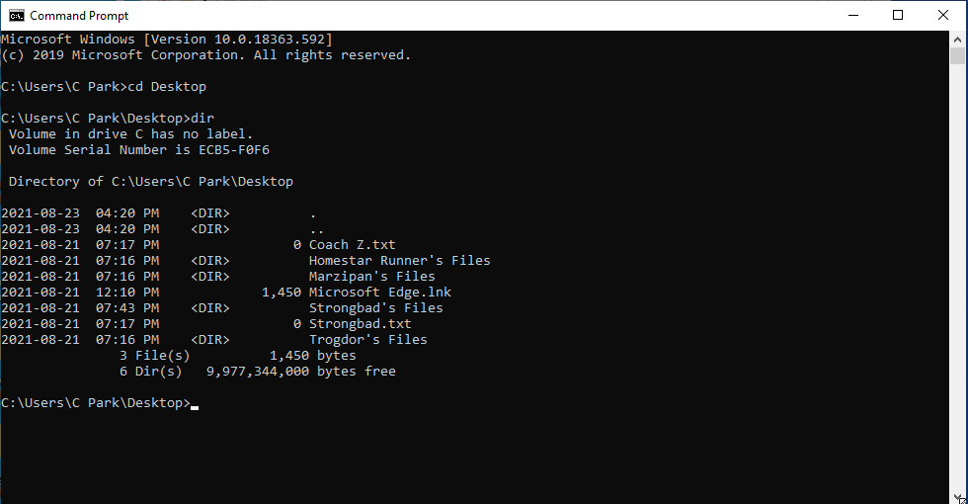

Hey! Your original file is shown **and** the copy you made with the new name applied. Looks like I was telling you the truth!

1. Think of a new name for your file, then type the following command  
   **ren “*oldfilename.txt*”“*newfilename.txt*”** and then press Enter. Note: you should put quotes around the file names – this is very important if you have spaces or other special characters in the file name, so it’s a good habit to get into. Note 2: where I used **oldfilename** you should type the name of **your** file, and where I used **newfilename** you should use the new name you picked for your file. You window will look something like this:

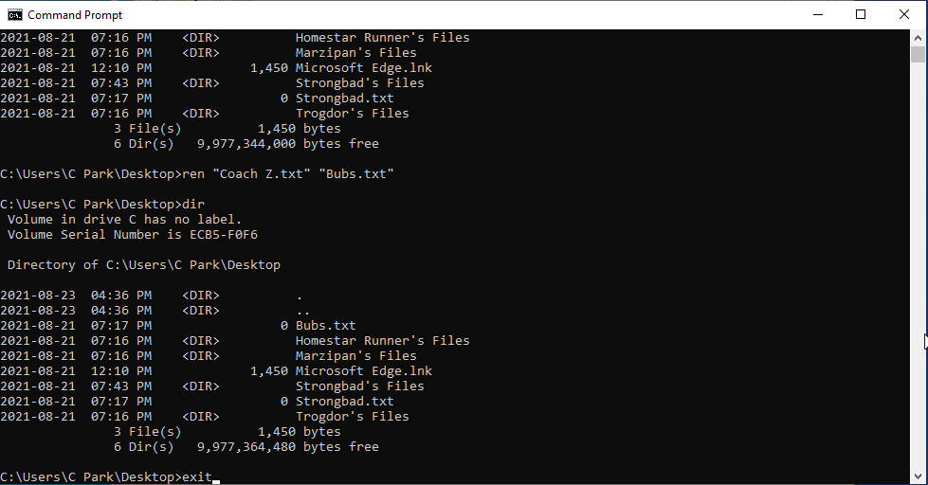

1. You may notice that I started entering a command at the end there, **exit**. Go ahead and type that and press Enter.  
     
    Question: What happened?  
     
    The command prompt window closed entirely.

You should notice that on both your workspace Desktop and in the File Explorer window the new file has changed to the name you specified in the previous step. This is because you used the **rename** command on the *CLI (Command Line Interface)* for windows – we call it the *Command Prompt*.   
  
You may have already used this interface in other classes. Now you know that you can manipulate your files in the same way as you do in the *GUI (Graphical User Interface)* workstation Desktop. These skills might help you work faster and more comfortably during those classes!

1. Open the Command Prompt CLI again. Once more, move to the Desktop folder by typing **cd Desktop** and pressing Enter.  
     
   Type the following command, but where I use the file name yourfile.txt you should substitute the new file name that you used in the previous section where you renamed the file (type the quotes): **del “yourfile.txt”**
2. Exit the Command Prompt window – you can use the **exit** command again, or you can click the “x” in the upper-right corner of the window.  
     
    Question: Is the file showing on your workspace Desktop?  
     
    No, it is gone. I am using Documents due to school privleges.

Question: Is the file showing in the File Explorer window (make sure you’ve descended into the Desktop directory).

No, it is gone.

Question: What do you think that command did?

Deleted my file and moved it to the recycle bin.  
I just checked and it’s not in my bin, it’s totally gone ☹

At this point in the lab you are going to do a little bit of research (Google is your friend!) and testing on your computer as you answer the following questions. Take your time getting these answers – it’s not a race, and in fact you’re going to want to understand these as they are important foundational knowledge that you’ll likely make use of for years to come.

1. Is the file you deleted via the CLI in the Recycle Bin?  
     
    No, sadly not. It is fully gone.
2. Can you put a file in a folder that is inside another folder?  
     
    Yes! I can put a directory in a directory
3. Assuming you ***can*** put a file in a folder that’s in another folder, it sure would be a lot of clicking and poking to drill down to. Wouldn’t it be nice if we could create a faster, more direct way to get to that file – a shortcut of some kind so that you could jump right to it from your Desktop? How would we do that?  
     
    Copy the file, Paste Shortcut where you want the easy access. So I would put a shortcut on my Desktop.
4. We made a copy of a file within the File Explorer. Could we do the same thing from the Command Prompt CLI?  
     
    Yes. Use the Copy command.  
   e.g. copy “yourfilename.ext”
5. Deleting many files one at a time would probably be tedious. How do you go about deleting multiple files using File Explorer?  
     
    Click, Hold and drag your mouse to make a selection box and then let go of the click. One you have all the files selected right cock and press delete. Or click the delete button on your keyboard
6. Does the same process work for renaming multiple files?  
     
    Yes, kinda. It does rename everything, but it only lets you enter a single name. Then everything else gets named “Name (#)”  
   e.g. test (1) test (2) test (3). If it’s a file and a directory they get renamed.  
     
   Because files can have the same names as folders they both start from 1  
   e.g  
   test (1) folder  
   test (1) file  
   test (2) folder  
   test (2) file
7. Does the same process work for copying multiple files?  
     
    Yes, I can select a bunch of files and directories and Copy them.
8. Can you move multiple files all at once into a folder?  
     
    Yes, easily.
9. If you click on “This PC” in File Explorer what do you see?  
     
    Folders, it looks like my quick access.  
   Devices and drives  
   Shows my C: drive called Windows.  
   Network locations  
   Apps (k:)  
     
   Folders, Devices and drives, Network locations
10. Under “Devices and drives” you’ll see something like “Local Disk (C:)”. What does the C: part mean?   
      
     C: means that is the drive letter   
    In my case the C drive is the main directory.  
    The drive letter is not the same as the name.

I can rename it, but not change the drive letter from the explorer.

1. Double-click on that Local Disk icon. You’ll see a list of objects. What kind of objects are most of them?  
     
    Folders or directories.
2. Double-click on the item named “Users”. What are the objects you now see?  
     
    3 directories  
   My student number: 000970878  
   Public  
   student.user
3. Double-click on the object with the same name as the name you used to login to the computer. What are the objects you now see?  
     
    directories and lots of them. I can see the styled folders like download and documents as well as other like Saved Games and OneDrive
4. Double-click on the item named “Desktop”. What do you now see, and is it familiar?  
     
    No, this is different than the one I saw before. It is empty.
5. Click to the right of the text in the navigation bar that’s just under the menu bar (note: you will have a different name in between the “Users” and the “Desktop” parts of the text):



The text rewrites itself a bit. What does it now say?  
  
 C:\Users\000970878\Desktop

1. Double-click on the folder icon in this directory. Once again, click to the right of the text in the navigation bar. What does the text in that bar now say?  
     
    I made a folder called Test, then double clicked it and then checked for the address.  
   C:\Users\000970878\Desktop\Test
2. Hit the -> cursor key several times – you want to make sure you’re at the end of the new text in that box, and you don’t want it to be selected. Use backspace to remove any text that’s after “Desktop\”, then press Enter. Where are you now?  
     
    I am back in the Desktop folder like I was before I double clicked the Test folder.

Congratulations! You’ve successfully made it to the end of this lab! Yay!

Now, save this file and upload it to the submission link on the course page. If you’re not sure how to do that, please ask! That’s what the Professor is for!